Project Design Phase
Solution Architecture

Date | 08\03\2026
Team ID | SWTID-2026-4737
Project Name | Product inventory management -np
Maximum Marks | 4 Marks

Solution Architecture:
The solution architecture for the Product Inventory Management System focuses on building a secure, scalable, and maintainable backend using Node.js, Express.js, and MongoDB. The backend provides RESTful APIs for authentication and product management while ensuring data privacy and security through JWT-based authorization.
The architecture follows a modular Model–View–Controller (MVC) structure, which separates application logic into different layers. This approach improves maintainability, scalability, and code organization, making it easier to extend the system with additional features in the future.
Goals of the Solution Architecture:

1. Identify the Best Technology Solution
- Utilize Node.js for high-performance server-side execution.
- Implement Express.js to create structured and efficient REST APIs.
- Use MongoDB as the database for flexible and scalable data storage.
- Implement JWT (JSON Web Tokens) for secure user authentication and authorization.

2. Define the System Structure and Characteristics
- Adopt a modular MVC architecture to separate concerns within the system.
- Organize the application into modules such as:
  - Authentication
  - Product Management
  - Middleware
  - Database Models
- Ensure the backend remains scalable, maintainable, and easy to manage as the system grows.

3. Outline Features and Development Phases
Development will be carried out in structured phases:
- Backend Setup
  - Configure Node.js server
  - Set up Express framework
  - Establish MongoDB database connection
- Authentication APIs
  - User registration
  - User login
  - JWT token generation and verification
- Product Management APIs
  - Create product
  - Read product data
  - Update product details
  - Delete products (CRUD operations)
- Testing and Validation
  - API testing
  - Error handling verification
  - Performance and security checks

4. Establish Specifications for Development and Delivery
- Follow REST API design standards for consistent endpoint structure.
- Use token-based authentication (JWT) to secure protected routes.
- Implement middleware for authentication, validation, and error handling.
- Optimize database queries and asynchronous operations to ensure fast response times and reliable system performance.
Flow chart:
- Architecture Diagram
- API Structure Table
- Database Schema (MongoDB collections)
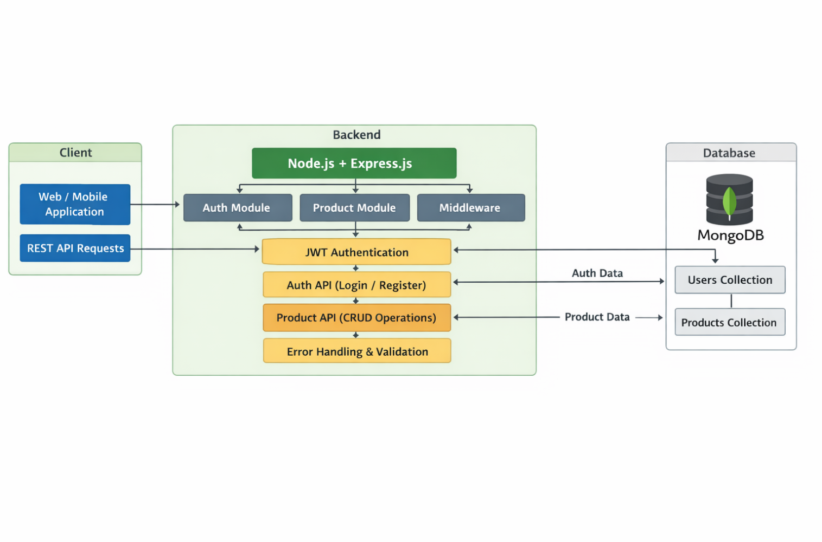
- Deployment Architectur

